A000-Afr-Ashanti-Chieftain holding Ceremonial Stool-Gold tone bronze-20th c



Figs 1-2. Afr-Ashanti-Chieftain holding Ceremonial Stool-Gold tone bronze-20th c

14 in. high, lost wax process, gold tone bronze.

Case No.: 6

**Accession No.**

**Formal Label:** Afr-Ashanti-Chieftain holding Ceremonial Stool-Gold tone bronze-20th c

**Display Description:**

It is intended that the symbolism of the stool becomes not only the property of the owner but also the identification of the owner's spirit and being. With this ontological symbolism it is important to prevent some one other than the owner to assume its ontological being by sitting on it or to allow a malevolent spirit to take charge of the stool and with it the owner's spirit. Therefore, often stools will be seen with their upper corners worn from being leaned up against the wall or laid down on their sides to prevent unauthorized use of it, as evident in this specimen.

**LC Classification:**

**Date or Time Horizon:**

**Geographical Area:**

**Map:**

**GPS coordinates:**

**Cultural Affiliation:**

**Media:**

**Dimensions:**

**Weight:**

**Condition:**

**Provenance:**

**Discussion:**

**References:**

Asihene, Emmanuel V. 1978. *Understanding the traditional art of Ghana.* Rutherford, Madison, Teaneck: Fairleigh Dickinson University Press; London: Associated University Presses.

[Sarpong](http://www.jstor.org.libproxy.mit.edu/action/doBasicSearch?Query=au%3A"Peter+Kwasi+Sarpong"&wc=on)[i](http://www.jstor.org.libproxy.mit.edu/stable/40456847?&Search=yes&searchText="Sese+tree"&list=hide&searchUri=%2Faction%2FdoBasicSearch%3FQuery%3D%2522Sese%2Btree%2522%26gw%3Djtx%26acc%3Don%26prq%3D%2522Sese%2B%2522%26Search%3DSearch%26hp%3D25%26wc%3Don&prevSearch=&item=1&ttl=1&returnArticleService=showFullText), [Peter Kwas](http://www.jstor.org.libproxy.mit.edu/action/doBasicSearch?Query=au%3A"Peter+Kwasi+Sarpong"&wc=on). The Sacred Stools of Ashanti, Anthropos, Bd. 62, H. 1./2. (1967), pp. 1-60.

**Appendix:**

Details of statuette

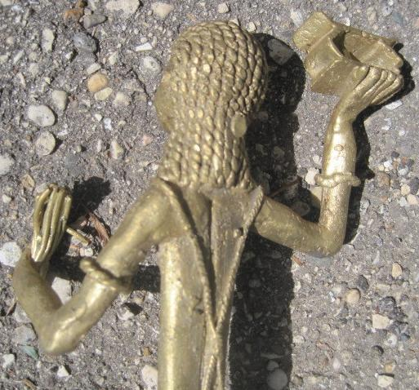

| Shipping details |
| --- |
| **Ralph J Coffman Jr**  149 Atlantic Ave  Swampscott MA 01907-2427  United States |

## Order details

|  |  |  |  |
| --- | --- | --- | --- |
| **Item title** | **Available actions** | **Shipping & handling (estimated delivery*)** | **Price** |

[Printer version](http://payments.ebay.com/ws/eBayISAPI.dll?ViewPaymentStatus&transid=1069309569012&userloginid=802-867&printerversion=true&itemid=220848329134)

|  |  |  |
| --- | --- | --- |
| Seller: | [**Member id** hcarey](http://myworld.ebay.com/hcarey) ( [**Feedback Score Of** 12653](http://feedback.ebay.com/ws/eBayISAPI.dll?ViewFeedback&userid=hcarey)) | [Contact seller](http://contact.ebay.com/ws/eBayISAPI.dll?ShowCoreAskSellerQuestion&frm=3998&iid=220848329134&redirect=0&requested=hcarey) |

|  |  |  |  |  |
| --- | --- | --- | --- | --- |
| Paid on Oct-05-12 via PayPal | | | | |
|  |  |  |  |  |

|  |  |  |  |  |  |  |  |  |
| --- | --- | --- | --- | --- | --- | --- | --- | --- |
|  | [**Item Title:**GOLD TONE METAL STATUE ASHANTE WARRIOR FROM GHANA AFRICA 14" TALL BASE 3 1/2" **- opens in a new window or tab**](http://cgi.ebay.com/ws/eBayISAPI.dll?ViewItem&item=220848329134)  **Item Id:**220848329134 - Price: US $35.00  Quantity:1  Having a problem with this purchase? [We can help](javascript:;) | |  | | --- | |  | | |  |  | | --- | --- | | [Leave feedback](http://feedback.ebay.com/ws/eBayISAPI.dll?LeaveFeedbackShow&useridfrom=802-867&useridto=hcarey&item=220848329134&transactid=1069309569012) |  | | | Economy Shipping : **US $15.00**  USPS Parcel Post®  Estimated delivery: October 10 - October 17  Delivered: 10/09/12  **Package 1 of 1**    Shipment details: [9434609699938197420648](javascript:;) | US $35.00 |



|  |  |  |  |  |
| --- | --- | --- | --- | --- |
|  | | |  | |
|  |  | |  |  |  |  |  |  |  |  |  |  |  |  |  |  |  |  |  |  | | --- | --- | --- | --- | --- | --- | --- | --- | --- | --- | --- | --- | --- | --- | --- | --- | --- | --- | | |  | | --- | | |  |  |  |  |  |  |  |  |  |  |  |  |  |  |  | | --- | --- | --- | --- | --- | --- | --- | --- | --- | --- | --- | --- | --- | --- | --- | | |  |  | | --- | --- | | Subtotal: | US $35.00 | |  | | | Shipping & handling: | US $15.00 | |  | | |  | | |  | | | Total: | US $50.00 | | | | | |  |